#####Home_work-1##########

EX1
Write C Program to Print a Sentence
i should see the Console as following
##########Console-output###
C Programming
###########################
The Solution
#define _CRT_SECURE_NO_WARNINGS
#include <stdio.h>
int main() {
printf("######Console-output###\n");
printf("C Programming");
printf("\n#######################");
return 0;
}
The Output
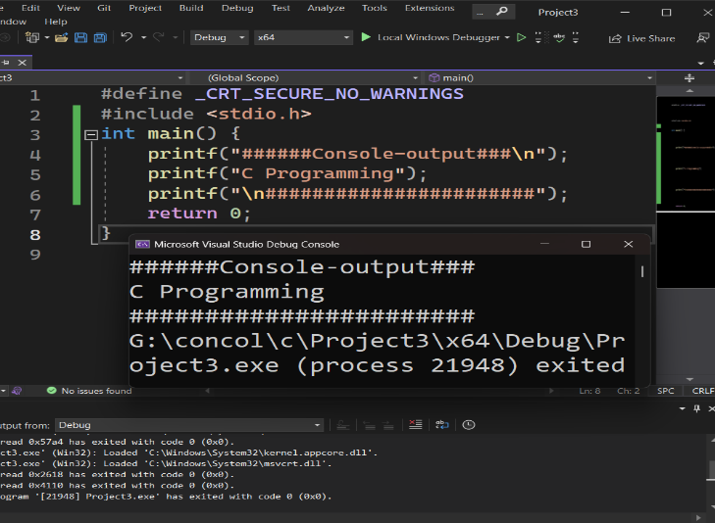
EX2
Write C Program to Print a Integer Entered by a User
i should see the Console as following
##########Console-output###
Enter a integer 25
You entered 25
###########################
The Solution
#define _CRT_SECURE_NO_WARNINGS
#include <stdio.h>
int main() {
int num;
printf("######Console-output###\n");
printf("Enter a integer:");
scanf("%d", &num);
printf("You entered:%d",num);
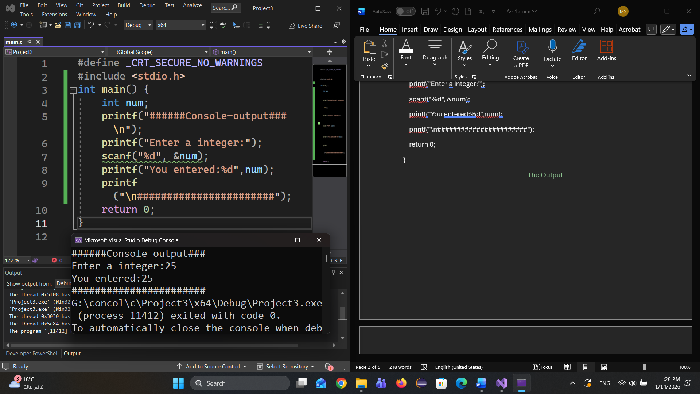
printf("\n#######################");
return 0;
}

The Output

EX3
Write C Program to Add Two Integers
i should see the Console as following
##########Console-output###
Enter two integers 12
11
Sum 23
###########################
The solution
#define _CRT_SECURE_NO_WARNINGS
#include <stdio.h>
int main() {
int num1,num2;
printf("######Console-output###\n");
printf("Enter two integers:");
scanf("%d", &num1);
scanf("%d", &num2);
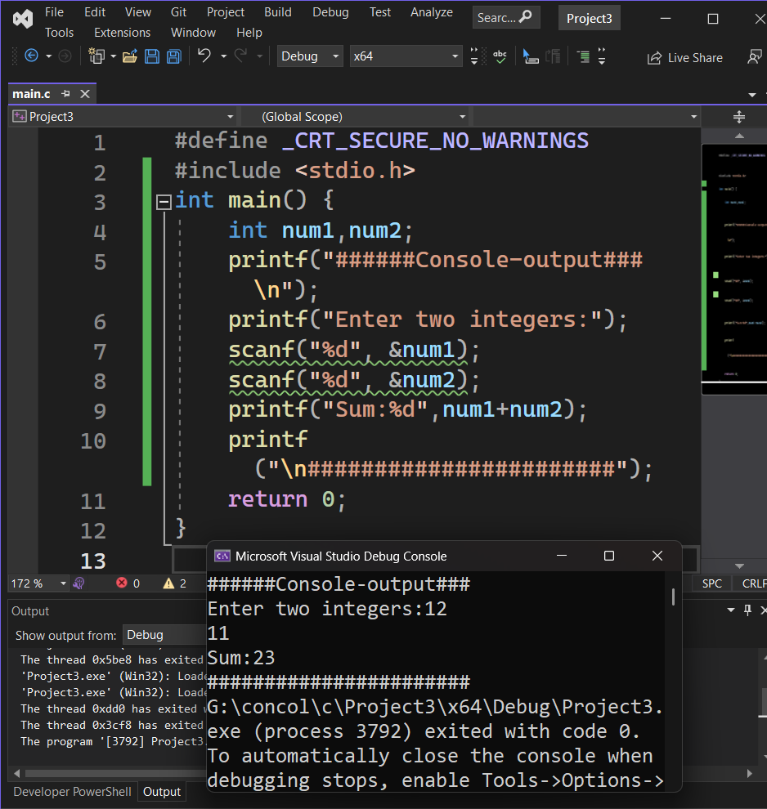
printf("Sum:%d",num1+num2);
printf("\n#######################");
return 0;
}

The Output

EX4
Write C Program to Multiply two Floating Point Numbers
i should see the Console as following
##########Console-output###
###########################
Enter two numbers 2.4
1.1
Product 2.640000
The Solution
#define _CRT_SECURE_NO_WARNINGS
#include <stdio.h>
int main() {
float num1,num2;
printf("######Console-output###\n");
printf("Enter two Number:");
scanf("%f", &num1);
scanf("%f", &num2);
printf("Product :%f",num1*num2);
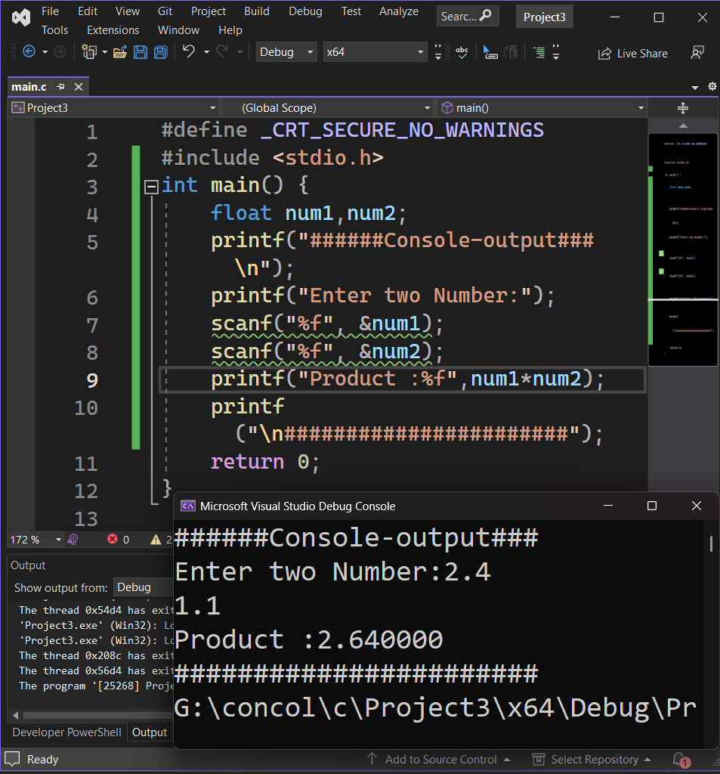
printf("\n#######################");
return 0;
}
The Output

EX5
Write C Program to Find ASCII Value of a Character
#########Console_output######
Enter a character G
ASCII value of G = 71
#############################
The solution
#define _CRT_SECURE_NO_WARNINGS
#include <stdio.h>
int main() {
char ch;
printf("######Console-output###\n");
printf("Enter a character :");
scanf("%c", &ch);
printf("ASCII value of %c %d",ch,ch);
printf("\n#######################");
return 0;
}
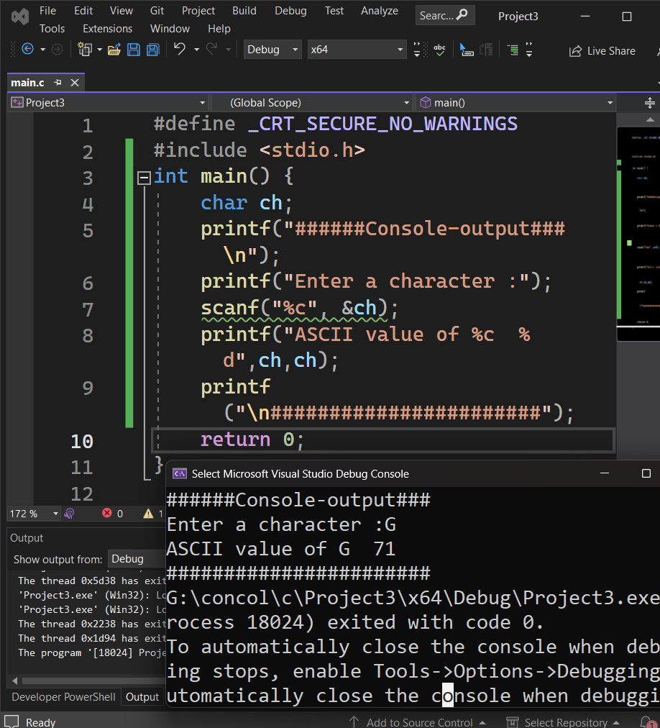
The Output

EX6
Write Source Code to Swap Two Numbers
#########Console_output######
Enter value of a 1.20
Enter value of b 2.45

After swapping, value of a = 2.45
After swapping, value of b = 1.2
#############################
The Solution
#define _CRT_SECURE_NO_WARNINGS
#include <stdio.h>
int main() {
float a,b;
printf("######Console-output###\n");
printf("Enter value of a:");
scanf("%f", &a);
printf("Enter value of b:");
scanf("%f", &b);
a = (b += (a -= b)) + b;
printf("After swapping, value of a = %f", a);
printf("\nAfter swapping, value of b = %f", b);
printf("\n#######################");
return 0;
}

Note : Swapping floats without a temporary variable is not recommended because floating-point numbers are stored approximately, not exactly. Arithmetic operations (addition/subtraction) can introduce rounding errors or overflow, leading to inaccurate results. Using a temporary variable avoids calculations and guarantees exact swapping.

The output

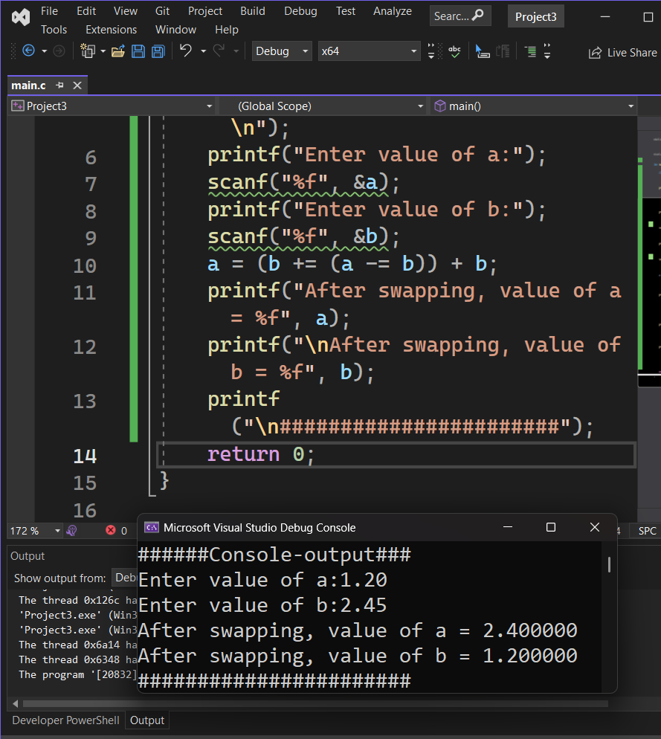

EX7
it is an interview trick

Write Source Code to Swap Two Numbers without temp variable.
a = (a + b) - (b = a);
a= (b+=(a - = b))+b ;
a = a * b;
b = a / b;
a = a / b;
a = a ^ b;
b = a ^ b;
a = a ^ b;
a = a + b;
b = a - b;
a = a - b;

